**Internal Combustion Lab**

**Topics:**

* Dynamometer
* Energy balance Experiment
* Frication calculation Experiment Using Willan’s Line
* Car Emissions
* Emission Control System (EGR)

ID: 4715

Name: Ibrahim Mostafa Ibrahim Elshenhapy

Group: 2

Section: 2

Dynamometer

A dynamometer is a power measurement instrument used to determination the work being done by a machine over time that can measure force, power, or speed.so you can figure out how much power you need or how much you have to hand. But dynamometers come in all shapes and sizes.

* A dynamometer allows us to measure power across a range of different power production systems. It is then possible to compare like for like and make adjustments.
* There are two different types of dynamometer which use power absorption and power transmission to measure power.

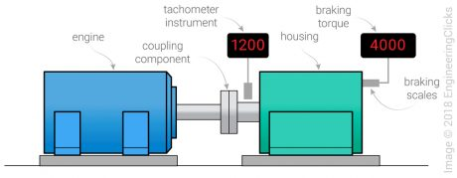Power absorption:

Power Absorption dynamometers measure and absorb the power output of the engine to which they are coupled. The power absorbed is usually dissipated as heat by some means.  
Examples of power absorption dynamometers are [Prony brake dynamometer](https://me-mechanicalengineering.com/dynamometer-introduction-types/" \l "prony_brake_dynamometer), [Rope brake dynamometer](https://me-mechanicalengineering.com/dynamometer-introduction-types/#rope_brake_dynamometer), [Eddy current dynamometer](https://me-mechanicalengineering.com/dynamometer-introduction-types/#eddy_current_dynanamometer), [Hydraulic dynamometer](https://me-mechanicalengineering.com/dynamometer-introduction-types/#hydraulic_dynamometer), etc.

* Coupling component that connects the dynamometer rotor with the driving shaft
* Tachometer instrument to measure the revolutions of the shaft
* A housing that interacts with the rotor in such a way that measurable braking torque is generated

If you've got an engine or motor, you can use a different kind of dynamometer to measure how much torque (turning force), power, or speed it can produce. Here, the dynamometer acts as a variable load that the engine/motor drives. It works by soaking up or absorbing the power that the engine/motor produces, so it's called an absorption dynamometerthat employ different sets of torque braking systems including:

* Magnetic powder placed between the dynamometer rotor and the coil
* A series of friction discs and steel plates in oil
* Water-brake stators that operate based on liquid friction

In addition to classification as absorption dynamometers can also be classified in other ways.

A dyno that is [coupled](https://en.wikipedia.org/wiki/Coupling) directly to an engine is known as an *engine dyno*.

A dyno that can measure torque and power delivered by the power train of a vehicle directly from the drive wheel or wheels without removing the engine from the frame of the vehicle), is known as a *chassis dyno*.

Dynamometers can also be classified by the type of absorption unit or absorber/driver that they use. Some units that are capable of absorption only can be combined with a motor to construct an absorber/driver or "universal" dynamometer.

Types of absorption units

* [Eddy current](https://en.wikipedia.org/wiki/Eddy_current_brake) (absorption only)
* Magnetic powder brake (absorption only)
* [Hysteresis](https://en.wikipedia.org/wiki/Hysteresis) brake (absorption only)
* [Electric motor](https://en.wikipedia.org/wiki/Electric_motor)/[generator](https://en.wikipedia.org/wiki/Electric_generator) (absorb or drive)
* Fan brake (absorption only)
* [Hydraulic](https://en.wikipedia.org/wiki/Hydraulic) brake (absorption only)
* Force lubricated, oil shear friction brake (absorption only)
* [Water brake](https://en.wikipedia.org/wiki/Water_brake) (absorption only)
* Compound dyno (usually an absorption dyno in tandem with an electric/motoring dyno)

Dynamometer Eddy Brake Absorber

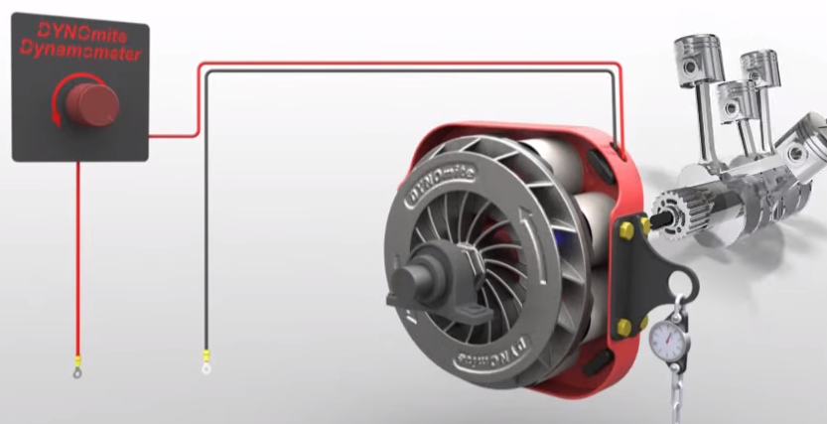An eddy current brake, also known as an induction brake, electric brake or electric retarder, is a device used to slow or stop a moving object by dissipating its [kinetic energy](https://en.wikipedia.org/wiki/Kinetic_energy) as heat. However, unlike [friction brakes](https://en.wikipedia.org/wiki/Friction_brake), in which the drag force that stops the moving object is provided by [friction](https://en.wikipedia.org/wiki/Friction) between two surfaces pressed together, the drag force in an eddy current brake is an electromagnetic force between a [magnet](https://en.wikipedia.org/wiki/Magnet) and a nearby [conductive](https://en.wikipedia.org/wiki/Electrical_conduction) object in relative motion, due to [eddy currents](https://en.wikipedia.org/wiki/Eddy_current) induced in the conductor through [electromagnetic induction](https://en.wikipedia.org/wiki/Electromagnetic_induction).

A conductive surface moving past a stationary magnet develops circular [electric currents](https://en.wikipedia.org/wiki/Electric_current) called [eddy currents](https://en.wikipedia.org/wiki/Eddy_current) induced in it by the [magnetic field](https://en.wikipedia.org/wiki/Magnetic_field), as described by [Faraday's law of induction](https://en.wikipedia.org/wiki/Faraday%27s_law_of_induction). By [Lenz's law](https://en.wikipedia.org/wiki/Lenz%27s_law), the circulating currents create their own magnetic field that opposes the field of the magnet. Thus the moving conductor experiences a drag force from the magnet that opposes its motion, proportional to its velocity. The [kinetic energy](https://en.wikipedia.org/wiki/Kinetic_energy) of the moving object is dissipated as [heat](https://en.wikipedia.org/wiki/Joule_heating) generated by the current flowing through the [electrical resistance](https://en.wikipedia.org/wiki/Electrical_resistance) of the conductor.

In an eddy current brake the magnetic field may be created by a [permanent magnet](https://en.wikipedia.org/wiki/Permanent_magnet) or an [electromagnet](https://en.wikipedia.org/wiki/Electromagnet), so the braking force can be turned on and off or varied by varying the [electric current](https://en.wikipedia.org/wiki/Electric_current) in the electromagnet windings. Another advantage is that since the brake does not work by [friction](https://en.wikipedia.org/wiki/Friction), there are no [brake shoe](https://en.wikipedia.org/wiki/Brake_shoe) surfaces to [wear](https://en.wikipedia.org/wiki/Wear) out, necessitating replacement, as with friction brakes. A disadvantage is that since the braking force is proportional to relative velocity of the brake, the brake has *no holding force* when the moving object is stationary, as is provided by [static friction](https://en.wikipedia.org/wiki/Static_friction) in a friction brake, so in vehicles it must be supplemented by a friction brake.

Eddy current brakes are used to slow high-speed trains and [roller coasters](https://en.wikipedia.org/wiki/Roller_coaster), as a complement for friction brakes in [semi-trailer trucks](https://en.wikipedia.org/wiki/Semi-trailer_trucks) to help prevent brake wear and overheating, to stop powered tools quickly when power is turned off, and in [electric meters](https://en.wikipedia.org/wiki/Electrical_meter#Electromechanical_meters) used by electric utilities.

Most chassis [dynamometers](https://en.wikipedia.org/wiki/Dynamometer) and many engine dynos use an eddy-current brake as a means of providing an electrically adjustable load on the engine. They are often referred to as an "absorber" in such applications.

Inexpensive air-cooled versions are typically used on chassis dynamometers, where their inherently high-inertia steel rotors are an asset rather than a liability. Conversely, performance engine dynamometers tend to utilize low-inertia, high RPM, liquid-cooled configurations. Downsides of eddy-current absorbers in such applications, compared to expensive AC-motor based dynamometers, is their inability to provide stall-speed (zero RPM) loading or to motor the engine - for starting or motoring (downhill simulation).

Also, since they do not actually absorb energy, provisions to transfer their radiated heat out of the test cell area must typically be provided. Either a high-volume air-ventilation or water-to-air heat exchanger adds additional cost and complexity. In contrast, the high-end AC-motor dynamometers cleanly return the engine's power to the grid.

Chassis Dynamometer

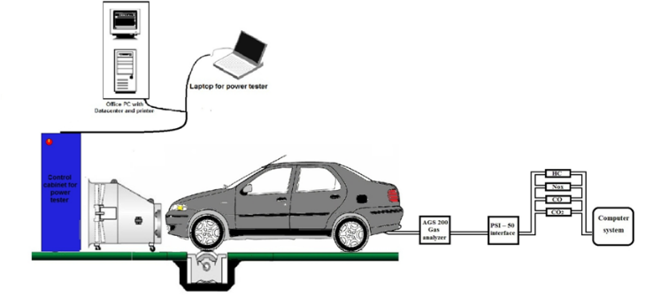A chassis dynamometer, sometimes called a rolling road, is a device used for vehicle testing and development. It uses a roller assembly to simulate a road in a controlled environment, usually inside a building.

There are many types of chassis dynamometer according to the target application - for example, emissions measurement, miles accumulation chassis dynamometer (MACD), Noise-Vibration-Harshness (NVH or "Acoustic") Application, Electromagnetic Compatibility (EMC) testing, end of line (EOL) tests, performance measurement and tuning. Another basic division is by type of vehicle - motorcycles, cars, trucks, tractors or the size of the roller - mostly 25", 48", 72", but also any other. Modern dynamometers used for development are mostly one roller to the wheel construction and the vehicle wheel is placed the top of the roller.

Directly measured variables are only force on the torque transducer and revolutions measured on the role encoder dynamometer. All other variables are calculated based on known design.

Due to friction and mechanical losses in various parts of the power train, the measured power at the wheels by about 15 to 20 percent lower than the power measured directly at the output of engine crankshaft (measuring device with this purpose is called engine testbed)

**Water Brake Dynamometer**

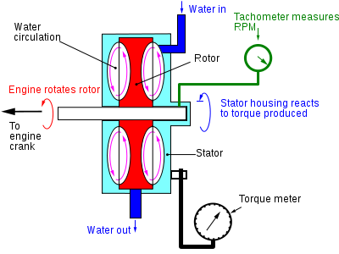The basic operation of a water brake dyno uses the principle of viscous coupling. The output shaft of the engine is coupled to a fan that spins inside a concentric housing. While the engine is running, the housing is filled with a controlled amount of water. The more water that is allowed into the housing, the more load the engine will feel.

As the fan spins through the water, the water is whipped around as well. Newton’s 3rd Law says that the water will push on by the housing with the equal and opposite force that the fan is pushing on the water. In this case, the shear forces in the water are acting tangential to the housing radius. There is a load cell at a measured distance from the center of the housing.  The load cell is also oriented perpendicular to the arm extending from the housing. The torque output of the engine is just the force measured at the load cell multiplied by the distance to where the extended arm and load cell connect.

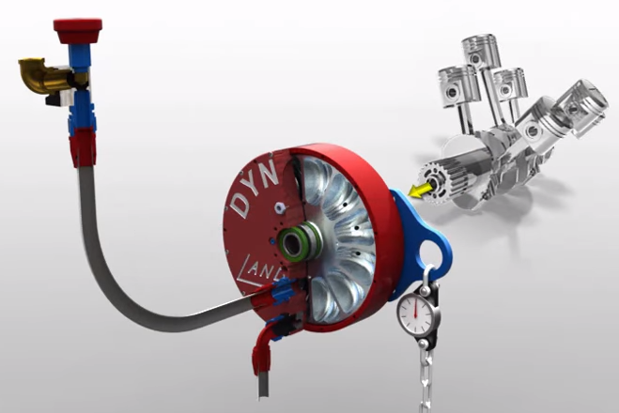

References

1. <https://www.engineeringclicks.com/dynamometer/>
2. <https://www.explainthatstuff.com/how-dynamometers-work.html>
3. <https://en.wikipedia.org/wiki/Dynamometer>
4. <https://www.dynomitedynamometer.com/dyno-tech-talk/examples/how-water-brakes-work-MAX-video.htm>
5. <http://courses.me.berkeley.edu/ME102B/Past_Proj/f03/Proj11/discuss.htm>
6. <https://en.wikipedia.org/wiki/Chassis_dynamometer>
7. <https://www.sciencedirect.com/topics/engineering/dynamometer>
8. <https://me-mechanicalengineering.com/dynamometer-introduction-types/>